ElderCare
FINANCIAL AWARENESS

YOUR MONEY

PRESENTER GUIDE

1

ElderCare | YOUR MONEY |

1 | PRESENTER GUIDE
ACKNOWLEDGEMENTS

These materials have been developed in furtherance of the work of the Public Outreach Committee of the National Conference of Bankruptcy Judges and through the volunteer efforts of the following:
Christopher W. Frost, Esq.
Frost, Brown, Todd Professor of Law, University of Kentucky College of Law, Lexington, Kentucky.
John Rosenberg, Esq.
Prestonsburg, Kentucky
Addison Parker, Esq. and Katherine S. Sanford, Esq.
Appalachian Research and Defense Fund of Kentucky, Inc., Richmond, Kentucky.
Anne Marie Regan, Esq.
Kentucky Equal Justice Center, Louisville, Kentucky.
Melissa Gross, PROGRAM DIRECTOR
Kentucky River Foothills Development Council, Richmond, Kentucky.
Rick Seckel, EXECUTIVE DIRECTOR
Kentucky Equal Justice Center, Lexington, Kentucky.
Sally Wilcox
AmeriCorps Financial Literacy Specialist, Maxwell Street Legal Clinic, Lexington, Kentucky.

In addition, the Committee recognizes the volunteer work of the following University of Kentucky College of Law students, with special thanks to Mary Katherine Parrott, University of Kentucky College of Law, Class of 2013, for her astute organizational and drafting skills:

Josh Berkley
Kelly Calder
Alexandra Crawley
Christine deBriffault
Karema Eldehan
Ian Forrest
2 | PRESENTER GUIDE | YOUR MONEY | ElderCare
Daniel Moon
Thaer Qasem
Brittany Riley
Sarah Tate
Erica Yartz
Laura Leigh Zimmerman

WELCOME, PRESENTERS

Welcome to the ElderCare program and thank you for putting in the time to teach this important material to senior citizens.
The unfortunate rise of financial elder abuse is extremely disturbing and we hope that the advent of this program will end the exploitation of some of our most valued citizens. As you use the ElderCare program, remember that senior citizens have wisdom to share and allow their experiences and thoughts to season your lessons. Be patient, and speak clearly.
You have the entire Participant Guide in this packet, and it’s often best to teach from that information. Elaborate when it is necessary. Introducing outside scenarios and experience is encouraged so that seniors apply the information to their everyday lives. Be creative: remember, this is valuable information, and seniors will appreciate the time you put in to help them!

Topics You’ll Be Covering
- Identifying the signs of a financial scam.
- Recognizing how identity theft can be harmful to a person’s financial assets.
- Learning how to protect individuals from different financial scams.
- Demonstrating the steps to take if a person suspects being a victim of
a financial scam.

Presentation Pointers
- Complete your presentation in an hour or less.
- Be sure to allow opportunities for interactive communication.
- Senior citizens are NOT teenagers or young adults—they do not process or retain information in the same way a young adult does.
- Presenters should gauge the level of “senior savvy” by asking interactive topical experience questions at the beginning of the presentation.
- Seniors are wise and proud—they may not be willing to ask questions if they don’t understand.
- Seniors learn best from one another. Consider asking them if their friends have experienced any of these situations, and encourage them to share their experiences.
3 | PRESENTER GUIDE | YOUR MONEY | ElderCare
TABLE OF CONTENTS

Introduction PAGE 5
Participant Guide, page 3
Identity Theft PAGE 7
Participant Guide, page 4
Types of Identity Theft
If You Think You Might Be a Victim
Lottery Scams PAGE 9
Participant Guide, page 5
Signs of a Lottery Scam
Lottery Scams Discussion
Utility Scams PAGE 12
Participant Guide, page 7
Types of Utility Scams
Home Improvement Scams PAGE 14
Participant Guide, page 8
Signs of a Home Improvement Scam
Signs of an Untrustworthy Contractor
Recognizing a High Pressure Sales Tactic
Home Improvement Scams Discussion

2

ElderCare | YOUR MONEY |

4 | PRESENTER GUIDE
FINANCIAL AWARENESS INTRODUCTION

The goal of the ElderCare program is to stop financial abuse of senior citizens and give you the tools to take control of your finances.

After going through this program, you will be able to:
- Recognize common financial scams.
- Understand the negative effects scams can have on your
financial resources.
- Identify trustworthy sources of financial advice and assistance.

Be S.M.A.A.R.T.
A recent study estimates that the elderly are swindled out of nearly $3 billion each year.

Another study found that 1 in 5 senior citizens had been the victim of a financial scam.

43% of Americans spend more money than they earn.
Stop! Take time to think through any financial decisions you make.
Make decisions on your own time, not because others pressure
you to decide quickly. Never fall for high-pressure sales tactics.
Avoid businesses that contact you directly. You know your
needs best and can contact services when you need them.
Ask questions about any financial deal you make. Know what
you are entering into and that it is exactly what you want.
Research your options before making decisions.
Talk to people you trust before making a financial decision.

5 | PRESENTER GUIDE
3
ElderCare | YOUR MONEY |
YOUR MONEY

OBJECTIVE: To educate seniors on the many ways that the theft and falsification of their identity can be used to financially scam them. By the end of the lesson, seniors should be able to better identify potential scams, know how to avoid them and know what steps to take if they become a victim of identity manipulation or theft.
TYPES OF SCAMS COVERED:
Each section begins with suggested “Introductory Topical Experience Questions”—use these questions (or similar ones) to introduce the topic and engage seniors in the discussions.
- Identity Theft
- Lottery Scams
- Utility Scams
- Home Improvement Scams
You should cover each topic in approximately 15 minutes.

6 | PRESENTER GUIDE | YOUR MONEY | ElderCare
YOUR MONEY | IDENTITY THEFT

This lesson is used to educate regarding the dangers of false identity/ identity theft. By the conclusion of the lesson, seniors should be able to:
- Better identify potential identity scams.
- Know how to take precautionary steps in order to avoid having their identity stolen.
- Know what steps to take should they find themselves a victim of identity theft.

Objective | Participants should be able to identify the common characteristics of false identity scams, including the different ways identity can be stolen, preventative steps to take to protect their identity, and steps to take should they find themselves a victim of identity theft.
Information | Reference identity theft lesson in participant guide.
Verification Activity | The presenter should engage in an interactive process with the participants. In this role playing activity, the presenter will play the role of scammer and the participants as receiver. This activity will reinforce identifying false identity scams as well as allow the participants an opportunity to safely exit the scam. With the “old fashioned” and “online” scenarios (i.e. dumpster diving, email, pop-up scenarios), the participants should identify steps to avoid falling victim to the scam.
Summary | Participants will leave the presentation being able to recognize the common characteristics and dangers of false identity scams. The presentation will help participants develop a response plan if they are confronted with a potential scam.
Introductory Topical Experience Questions
- Dumpster Diving: How do you dispose of your bank statements? Do you throw them in the trash? Do you shred them?
- Telephone Calling and Medicare Identity Theft: Have you ever received a call from a person that you suspected wasn’t honest about his true identity? Did they ask you for personal information?
- Hacking and Phishing: How many of you have a computer in your home? What types of activities do you do on the computer? Do you email family members and friends? Do you pay your bills online? Do you shop online? Do you bank online?
Act out hypothetical situations where you act as a caller who is trying to financially scam a senior. Use high pressure tactics but give them a way out.
7 | PRESENTER GUIDE | YOUR MONEY | ElderCare
YOUR MONEY | IDENTITY THEFT

There are many ways that scammers can run away with your money. One of the most common ways is by taking or manipulating your personal information.
Identity theft occurs when your personal information is stolen and used to commit fraud or other crimes. It can be financially devastating and ruin your credit. There are many different ways your identity and personal information can be compromised.
Types of Identity Theft
PROTECT YOURSELF
Be suspicious of any requests that ask you to wire money.
Make your passwords difficult to guess. Use a combination of numbers, letters and symbols.
Never provide personal information to anyone via email.
Never give out personal information on the phone unless you’ve confirmed the identity of the person or organization.
Shred all documents that contain your personal information before throwing them away.
Do not submit personal information online, including payment information, unless you are sure you are using a secure internet connection.
Dumpster Diving. Stealing documents containing personal
information from your trash.
Old Fashioned Stealing. Taking your purse, wallet, mail, etc.
to obtain your personal information.
Telephone Calling. Calling you and pretending to be a friend,
a government agency or a bank and asking for your personal
information.
Hacking. Hacking into your email or other online accounts to
obtain personal information.
Phishing. Pretending to be credit card companies or other
organizations and seeking personal information from you via
telephone calls, emails or online pop-up ads.
Medicare Identity Theft. Caller pretending to be a Medicare representative to obtain your personal information to steal from Medicare or from your personal accounts.
If You Think You Might Be a Victim
Contact your local law enforcement.
Contact a credit reporting agency to place a fraud alert on your
account and to determine if any accounts have been opened in
your name.
Contact your creditors to notify them of the theft. Close your
accounts if necessary.
File a complaint with the Federal Trade Commission.
Keep track of any documentation showing identity theft.
ElderCare | YOUR MONEY |

8 | PRESENTER GUIDE
4
YOUR MONEY | LOTTERY SCAMS

This lesson should be used to educate seniors about the dangers of lottery scams. By the conclusion of the lesson, participants should be able to:
- Understand the dangers of lottery scams.
- Identify common characteristics of lottery scams.
- Develop defense tactics against lottery scammers.
- Find resources that help victims of lottery scams and report potential lottery scams.

Objectives | Participants should be able to identify the common characteristics of lottery scams, including all the ways they can be deceived into sending money abroad. By understanding the dangers and characteristics, participants should develop a sense of skepticism about winning foreign lotteries. The presenter should emphasize that anyone could be a victim of a lottery scam so as to ensure victims won’t feel embarrassed.
Information | Reference Lottery Scam lesson in the participant guide.
Verification Activity | Group discussion of a real-life hypothetical situation. Decide what actions the group thinks would be appropriate to take in the hypothetical circumstances.
Summary | Participants will leave the presentation being able to recognize the common characteristics and dangers of lottery scams. The presentation will help participants develop a response plan if they are confronted with a potential lottery scam.

Introductory Topical Experience Questions
- Telephone Lottery Scams: Has anyone received a call saying you won a prize?
- Mail and Email Lottery Scams: Has anyone received a letter or email claiming that you won a large amount of money?
Read and discuss the “Tom in Trouble” hypothetical at the end of this section.
9 | PRESENTER GUIDE | YOUR MONEY | ElderCare
YOUR MONEY | LOTTERY SCAMS

What could be better than receiving a phone call, email or letter saying you’ve won money? Unfortunately, this could be another way for financial scammers to take advantage of you. It’s called a lottery scam.
Signs of a Lottery Scam
PROTECT YOURSELF
If it sounds too good to be true, it probably is. Unsolicited phone calls, emails and letters promising you’ve won lots of money should not be trusted.
If they call you, hang up.
If they write you, throw it away.
If they email you, mark it as spam and don’t answer it.
Remember, no real lottery will ever ask you for money to claim a prize.
Never give out personal information or credit card information over the phone.
You receive an unsolicited phone call, email or letter saying
you’ve won a lot of money.
You are told you must pay money or give out personal
information in order to claim a prize.

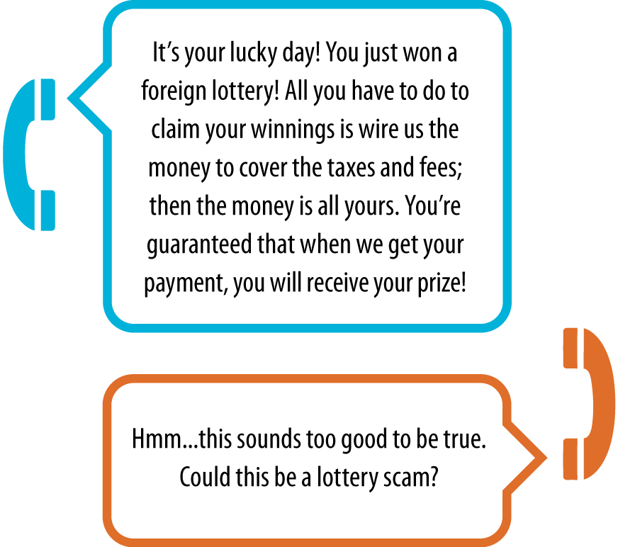

ElderCare | YOUR MONEY |

10 | PRESENTER GUIDE
5
YOUR MONEY | LOTTERY SCAMS DISCUSSION

Tom in Trouble—What would you do?
Tom is a 72-year-old father of three children, and he has four grandchildren. He is a retired, well-educated professional. Because of the nation’s recent financial crisis, many of Tom’s investments have failed. He finds himself unable to afford the retirement he had hoped for and unable to help out his loved ones as much as he had planned.
Tom received a call from a man who told him that he won a million dollars in a Canadian lottery but before he could collect the money, he would have to pay taxes. Tom was very excited; he finally had a stroke of good luck! The man told him to send a cashier’s check for $750 to their representative in Jamaica. Over the next year, Tom sent money on 13 occasions, totaling almost $100,000. The last payment sent was for about $20,000. The bank put a stop on this transaction and informed Tom that he was probably the victim of a scam. Tom was now in a much worse financial situation than he was before. He had lost his retirement in hopes of eventually receiving lottery winnings. Since last month, the man has left over a dozen voicemail messages for Tom. Tom has stopped taking his calls.

1. Where did Tom go wrong?
2. What should Tom have done when the man first contacted him?
3. What should Tom do now?
4. What can people in Tom’s shoes do to protect themselves from these types of frauds?

ElderCare | YOUR MONEY |

11 | PRESENTER GUIDE
6
YOUR MONEY | UTILITY SCAMS

This lesson should be used to educate seniors about the dangers of utility scams. By the conclusion of the lesson, seniors should be able to:
- Understand the financial dangers of utility scams.
- Identify common sales tactics used by utility scam artists.
- Develop responses/action plans to combat high-pressure sales tactics used by utility scam artists.

Objectives | Participants should be able to identify the common characteristics of utility scams, including common sales tactics and the sequence of events that usually lead to the perpetration of these scams. By understanding the dangers and characteristics, participants will develop a response plan to help combat the misleading solicitations and contacts regarding utilities.
Information | Talk about the various forms that utility scams can take:  • Utility Insurance Scams  • Utility Provider Change Scams  • Utility Account Information and Identity Theft
Verification Activity | Group discussion of a real-life hypothetical situation. Decide what actions the group thinks would be appropriate to take in the hypothetical circumstances.
Summary | Participants will leave the presentation being able to recognize the common characteristics and dangers of utility scams. The presentation will help participants develop a response plan if they are confronted with a potential utility scam.

Introductory Topical Experience Questions
- Utility Provider Change Scams: Has anyone received a letter that looks like it came from your utility company but it asked you to buy “utility insurance” or a cheaper service?
- Utility Identity Theft: How do you dispose of your monthly utility bill? Has anyone received mail from a “utility company” that you believe wasn’t really from your service provider?
12 | PRESENTER GUIDE | YOUR MONEY | ElderCare
YOUR MONEY | UTILITY SCAMS

Financial scammers often try to infiltrate the everyday transactions in our lives. A growing form of fraud involves one of the most common parts of our lives, and one we often don’t think about: utility scams for services like gas, water and electricity.

Types of Utility Scams
PROTECT YOURSELF
Utility insurance is never mandatory.
It can be tempting to purchase
utility insurance but you can
provide yourself the same coverage by saving a little each month to cover an unexpected repair expense.
Never show a door-to-door salesman your bill!
Never sign anything too quickly—take time to read it and get help from people you trust.
Never give out personal information or credit card information over the phone.
Shred your bill each month after you pay it so that your information doesn’t fall into the wrong hands.
1. Utility Insurance Scams
Utility insurance allows a homeowner to insure utility lines (like telephone and water lines) against costly damage. Utility insurance itself is legitimate, but often the solicitation by companies who are selling it is misleading. Letters urging you to buy insurance often appear to come from the utility company itself or tell you that insurance is mandatory.

2. Utility Provider Change Scams
Financial scammers from third party companies will try to trick you into switching to their service and then charge you hidden or increased fees.
They may come to your house claiming they can save you money and asking to see your personal account information.

3. Utility Identity Theft
Utility account information can make it easy for a financial scammer to steal your identity.
Scammers may call and claim your bill is overdue, asking you to give them your account information and credit card number so they can quickly pay the bill. After they get this personal information, they can use your cards to make purchases online or even to pay their own utility bills.

ElderCare | YOUR MONEY |

13 | PRESENTER GUIDE
7
YOUR MONEY | HOME IMPROVEMENT SCAMS

This lesson should be used to educate seniors about the dangers of mortgage scams. By the conclusion of the lesson, participants should be able to:
- Understand the dangers of home improvement scams.
- Identify common sales tactics and characteristics of home repair scammers.
- Develop defense tactics against home improvement scammers.

Objectives | Participants should be able to identify the common characteristics of predatory loans and foreclosure rescue scams. By understanding the dangers and characteristics of risky loans, participants will be able to make beneficial financial decisions.
Information | Review the Home Improvement Scams lesson in the participant guide.
Verification Activity | Group discussion of a real-life hypothetical situation. Decide what actions the group thinks would be appropriate to take in the hypothetical circumstances.
Summary | Participants will leave the presentation being able to recognize the common characteristics and dangers of predatory loans/risky loans and foreclosure scams.

Introductory Topical Experience Questions
- Untrustworthy Contractors: Has anyone been visited by a door-to-door home repair salesman? Did that person pressure you to commit to purchase their product or service immediately?
- High Pressure Sales Tactic: Has anyone been offered a repair service for a “special deal,” and then been charged a higher price? Did the service provider give you a reason for the price change? Was it reasonable?
Discuss what high-pressure sales tactics look like and how to avoid home improvement scams. Ask seniors to share stories about when they have heard of (or experienced) this happening. Discussion questions are included at the end of this section.
14 | PRESENTER GUIDE | YOUR MONEY | ElderCare
YOUR MONEY | HOME IMPROVEMENT SCAMS

Homes require a lot of care, and financial scammers know that people are willing to spend a lot of money to fix up their homes or restore them after a storm or disaster. Home improvement scams, usually carried out by contractors, take advantage of this vulnerability and can be extremely costly.
Signs of a Home Improvement Scam
PROTECT YOURSELF
Take time to think about a
contractor’s offer. Don’t sign
anything on the spot.
Don’t deal with door-to-door salespeople. Get recommendations from friends and family you trust.
Always get multiple estimates on home repair work.
Make sure a contractor provides you with a written contract agreeing to do the work you want done.
Don’t let a contractor start work on your home until all financial arrangements are final and you are comfortable with them.
- Unsolicited offers for home repairs.
- High pressure sales tactics.
Signs of an Untrustworthy Contractor
- He solicits door-to-door and doesn’t provide company
information or references.
- She pressures you to sign a contract immediately.
- He asks for cash payment or a check made payable to an
individual, not a company.
- She uses more than one contract for a single home repair
in order to confuse you and hide the cost of the work.
- He starts the work before you have a chance to see the
financing terms.
- She adds extra, hidden charges above the negotiated price.
- He claims there is a “cash” contract that doesn’t contain
financing terms, although the deal is intended to be financed.
Recognizing a High Pressure Sales Tactic
- A contractor uses a “bait and switch” tactic. He initially offers
a low price then later raises the price for a false reason.
- A contractor misrepresents the urgency of the repair or the
finance terms.
- A contractor claims that you are receiving a discount, but in
reality you are paying market price.
ElderCare | YOUR MONEY |

15 | PRESENTER GUIDE
8
YOUR MONEY | HOME IMPROVEMENT
SCAMS DISCUSSION

How can I recognize a high pressure sales tactic?

1. What does a “bait and switch” sales tactic look like? Think of a scenario and explain how this could be used to scam you.
2. What are the consequences of committing to a contractor before you’ve signed a paper agreement that details the work he will do?
3. How could high pressure sales tactics be enticing to people who need home improvement work done? How can you avoid giving in to people who try to pressure you into something?

ElderCare | YOUR MONEY |

16 | PRESENTER GUIDE
9

